Smart Parking System


Submitted by:
Aima Eman Aziz (65113)
Shumaila (65114)
Tayyaba Jahangir Abbasi (62550)
Alisha Nasreen (63122)
Khansa Kaleem (62607)

Faculty of Computing
Riphah International University, Islamabad
Spring 2026
A Dissertation Submitted To

Faculty of Computing,
Riphah International University, Islamabad
As a Partial Fulfillment of the Requirement for the Course
Human Computer Interaction

Bachelors of Science in Software Engineering
“Find It. Book It. Park It.”

Faculty of Computing
Riphah International University, Islamabad
Dedication/Acknowledgment
Thanks to Allah Almighty who made us able to complete this final project report. Also our course teacher who guided us in this project. All the members of the team who
worked hard and diligently to complete this project.
___________________
Aima Eman Aziz
65113
___________________________
Shumaila
65114
___________________________
Tayyaba Jahangir
62550
___________________________
Alisha Nasreen
63122
___________________________

Khansa Kaleem
62607
___________________________

Table of Contents

Contents | Page No.
Artifact – 1: Problem Statement / Project Proposal | 1
1.1 Description | 2
1.2 Literature Survey | 3
1.3 Systems and Feature Mapping | 5
1.4 Use-Case Diagram | 7
Artifact – 2: Interviews & Personas | 8
2.1 Conduct User Interviews | 9
2.1.1 Interview of Driver | 9
2.1.2 Interview of Parking Manager | 10
2.1.3 Interview of Security Guard / Parking Attendant | 11
2.2 Personas | 13
2.2.1 Persona 01 | 13
2.2.2 Persona 02 | 14
2.2.3 Persona 03 | 15
2.2.4 Persona 04 | 16
Artifact – 3: Prototype | 17
3.1 Low-Fidelity Wireframes | 18
3.2 High-Fidelity Prototype | 50
3.3 Figma Video Link | 97
3.4 Blender Logo | 97
Lesson Learned | 98
Conclusion | 99

Artifact-1
Problem Statement/Project Proposal

Project Proposal
Project Title: Smart Parking System

1.1 Description:
In crowded urban environments such as university campuses, shopping malls, and public areas, finding an available parking space has become a daily challenge. Drivers currently waste significant time and fuel driving around in search of empty slots, which leads to traffic congestion, increased frustration, and environmental pollution. Traditional parking systems lack real-time information and digital integration, leaving users with no way to check availability before arriving at a location. Furthermore, poor interface design and the absence of interactive features make it difficult for users to manage their parking efficiently.
We are going to develop a Smart Parking System that provides a digital platform allowing users to easily find, reserve, and navigate to available parking spaces through mobile and web applications. The system will utilize sensors or cameras to detect parking slot occupancy in real time. Users can view slot availability (available, occupied, or reserved), book a slot in advance, and make secure digital payments — all from their device. An integrated navigation system will guide users directly to their reserved parking location, eliminating the need to search aimlessly.
This system will significantly improve the parking experience. By providing real-time updates and an intuitive user-centered interface, it will reduce time spent searching for parking, decrease traffic congestion, and enhance overall user satisfaction. Proper user management will ensure secure access, while the digital payment system enables fast and hassle-free transactions. By adopting this smart, interactive solution, parking management becomes efficient, user-friendly, and environmentally conscious.

1.2 Literature Survey
Existing Features Description
Feature ID | Feature Name | Description
F-1 | User Signup or Login | This feature enables the user to sign up or log in to the system. For signup, email or phone number will be verified, and for login, password will be verified.
F-2 | Real-time Parking Slot Availability | Users can view real-time status of parking slots (available, occupied, or reserved) on an interactive map.
F-3 | Book or Reserve Parking Slot | Users can book or reserve a parking slot for a specific time and date. The slot will be held until the user arrives.
F-4 | Cancel Reservation | Allows the user to cancel a previously booked parking slot within a specified time window.
F-5 | Navigation to Parking Slot | Provides turn-by-turn navigation directions to the exact reserved parking location within the parking area.
F-6 | Digital Payment System | Enables users to pay parking fees online using credit/debit cards or mobile wallets. A digital receipt is generated.
F-7 | View Parking History | Users can view past parking records including date, time, duration, and payment details.
F-8 | User Profile Management | Allows users to manage profile information such as name, email, phone number, and vehicle details.
F-9 | Parking Fee Calculator | Users can calculate total parking fee based on duration before confirming booking.
F-10 | Nearby Parking Search | Users can search for available parking lots near their current location or a specified destination.
F-11 | Favorite Parking Locations | Users can save frequently used parking locations for quick access and booking.
F-12 | Real-time Notifications | Sends push notifications for booking confirmation, reservation expiry, payment success, or reminders.
F-13 | Admin Dashboard | Allows admin to manage parking slots (add/update/delete), monitor occupancy, manage pricing, and generate reports.
F-14 | Parking Slot Map View | Displays a visual layout of parking area showing exact positions of available and occupied slots.
F-15 | Time Extension Request | Users can request to extend parking duration if needed, subject to availability.

1.3 Systems and Feature Mapping:
Surveyed Systems:
S1: ParkMe
S2: SpotHero
S3: ParkMobile
S4: JustPark
S5: EasyPark
S6: Smart Parking Limited
S7: Flowbird
S8: ParkWhiz
S9: Get My Parking
S10: Dubai Smart Parking
S11: Parkopedia
S12: PayByPhone
S13: ParkJockey
S14: AirGarage
S15: Passport Parking
S16: Smart Parking System

Feature ID | S1 | S2 | S3 | S4 | S5 | S6 | S7 | S8 | S9 | S10 | S11 | S12 | S13 | S14 | S15 | S16
F-1 | ✓ | ✓ | ✓ | ✓ | ✓ | ✓ | ✓ | ✓ | ✓ | ✓ | ✓ | ✓ | ✓ | ✓ | ✓ | ✓
F-2 | ✓ | ✓ | ✓ | ✓ | ✗ | ✓ | ✗ | ✓ | ✓ | ✓ | ✓ | ✗ | ✓ | ✓ | ✓ | ✓
F-3 | ✓ | ✓ | ✓ | ✓ | ✗ | ✓ | ✗ | ✓ | ✓ | ✓ | ✓ | ✗ | ✓ | ✓ | ✓ | ✓
F-4 | ✓ | ✓ | ✓ | ✓ | ✗ | ✓ | ✗ | ✓ | ✓ | ✓ | ✗ | ✗ | ✓ | ✓ | ✓ | ✓
F-5 | ✓ | ✓ | ✓ | ✓ | ✗ | ✓ | ✗ | ✓ | ✓ | ✓ | ✓ | ✗ | ✓ | ✗ | ✓ | ✓
F-6 | ✓ | ✓ | ✓ | ✓ | ✓ | ✓ | ✓ | ✓ | ✓ | ✓ | ✓ | ✓ | ✓ | ✓ | ✓ | ✓
F-7 | ✓ | ✓ | ✓ | ✓ | ✓ | ✗ | ✗ | ✓ | ✗ | ✓ | ✓ | ✓ | ✓ | ✗ | ✓ | ✓
F-8 | ✓ | ✓ | ✓ | ✓ | ✓ | ✓ | ✓ | ✓ | ✓ | ✓ | ✓ | ✓ | ✓ | ✓ | ✓ | ✓
F-9 | ✓ | ✓ | ✓ | ✓ | ✓ | ✗ | ✓ | ✓ | ✗ | ✓ | ✓ | ✓ | ✗ | ✓ | ✓ | ✓
F-10 | ✓ | ✓ | ✓ | ✓ | ✓ | ✓ | ✓ | ✓ | ✓ | ✓ | ✓ | ✓ | ✓ | ✓ | ✓ | ✓
F-11 | ✓ | ✓ | ✓ | ✓ | ✗ | ✗ | ✗ | ✓ | ✗ | ✓ | ✓ | ✗ | ✓ | ✗ | ✓ | ✓
F-12 | ✓ | ✓ | ✓ | ✓ | ✓ | ✓ | ✓ | ✓ | ✓ | ✓ | ✓ | ✓ | ✓ | ✓ | ✓ | ✓
F-13 | ✗ | ✓ | ✗ | ✓ | ✗ | ✓ | ✗ | ✗ | ✓ | ✓ | ✗ | ✗ | ✓ | ✗ | ✓ | ✓
F-14 | ✓ | ✓ | ✓ | ✓ | ✗ | ✓ | ✗ | ✓ | ✓ | ✓ | ✓ | ✗ | ✓ | ✗ | ✓ | ✓
F-15 | ✗ | ✓ | ✓ | ✓ | ✓ | ✗ | ✗ | ✓ | ✗ | ✗ | ✗ | ✓ | ✓ | ✗ | ✗ | ✓

1.4 Use-Case diagram:
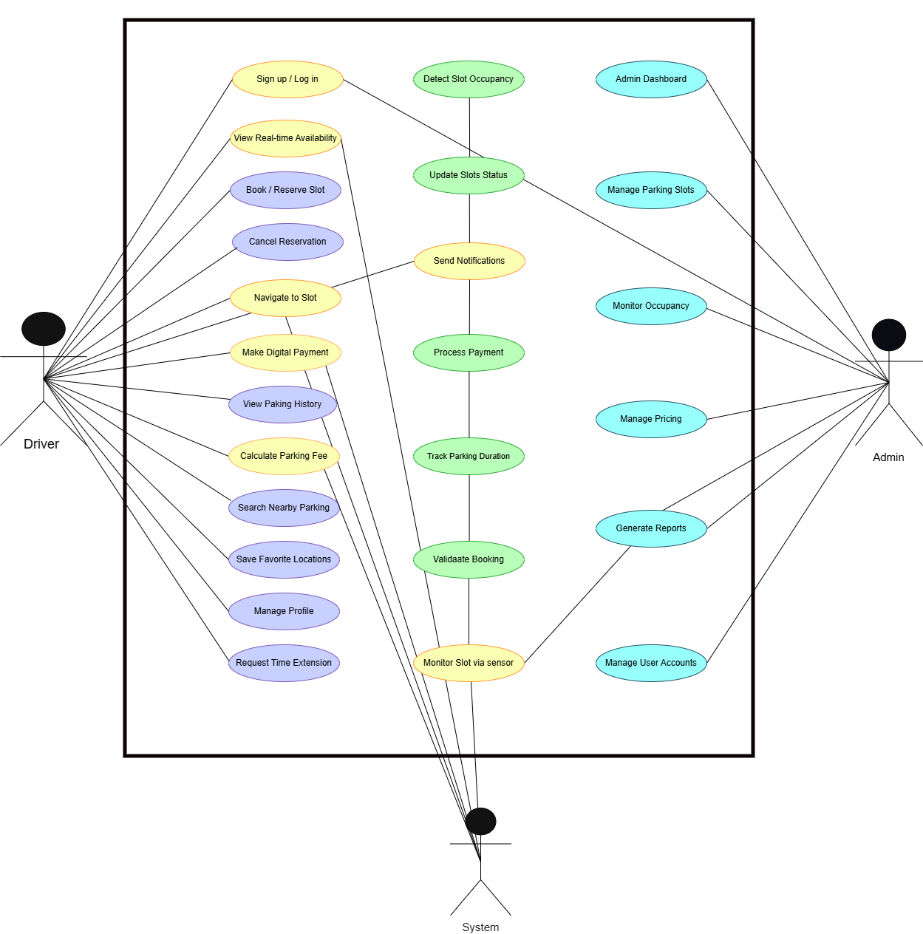
Figure 1 : Use Case Diagram

Artifact-2
Interviews & Personas

2.1 Conduct User Interviews
2.1.1 Interview of Driver
Field | Information
Interviewee | Usman Ahmed
Role/Designation | University Student / Regular Driver
Date | 10-04-2026
Time | 2:00 – 2:15 PM
Venue | Islamabad, Pakistan
Subject/Focus | Persona creation

Objectives:
Time | Question | Response | Observations
7 sec | What is your name? | My name is Usman Ahmed. | First name Usman, last name Ahmed
5 sec | What is your age? | I am 24. | He is 24 years old
6 sec | What do you do? | I am a university student and work part-time. | Student + working
15 sec | Where do you usually drive? | University, malls, workplace | Daily commute
30 sec | Time spent finding parking? | 30–45 minutes daily | Time waste
20 sec | Difficulty finding parking? | Yes, almost every day | Major issue
22 sec | Use any parking app? | No | No solution used
15 sec | Tech skill (1–10)? | 8/10 | Tech-savvy
10 sec | Device used? | Mobile phone | Mobile primary
7 sec | Internet issues? | 2–3 days/month | Stable internet
8 sec | Android or iOS? | Android | Flexible
25 sec | Book parking in advance? | Yes | Strong need
24 sec | App or website? | Mobile app | Prefers app
30 sec | Extra payment willingness? | 50–100 PKR | Willing to pay
1 min | Problems in current system? | No real-time info, no digital payment, wasted fuel | Core issues
24 sec | Real-time system useful? | 100% yes | Strong support

2.1.2 Interview of Parking Manager
Field | Information
Interviewee | Sana Khalid
Role/Designation | Parking Manager
Date | 10-04-2026
Time | 3:00 – 3:15 PM
Venue | Rawalpindi, Pakistan
Subject/Focus | Persona creation

Objectives:
Time | Question | Response | Observations
7 sec | What is your full name? | My name is Sana Khalid. | First name Sana, last name Khalid
5 sec | What is your age? | I am 32 years old. | She is 32 years old
6 sec | What is your current job or role? | I am a parking manager at a large shopping mall. | She manages parking operations
15 sec | How many parking slots are available in your facility? | We have around 500 parking slots. | Large parking capacity
30 sec | What are the main challenges you face in managing parking? | Peak hours are very difficult, drivers argue over spots, and we don’t have real-time data. | Major issues: chaos and lack of data
20 sec | How do you currently manage the parking system? | We use a manual system with security guards and paper slips. | Fully manual system
22 sec | Do you use any digital parking management system? | No, everything is manual because digital systems are expensive. | No automation
15 sec | How would you rate your technology skills on a scale of 1 to 10? | I would rate myself 7 out of 10. | Moderately tech-savvy
10 sec | Which devices do you commonly use for work? | I use a desktop at work and a mobile phone at home. | Uses both devices
7 sec | How often do you face internet connectivity issues? | Hardly ever, maybe once a month. | Internet is reliable
8 sec | Which operating system do you prefer, Android or iOS? | I use both Android and iOS devices. | Flexible user
25 sec | Would an admin dashboard help you manage parking more efficiently? | Yes, it would help me monitor occupancy, track payments, and generate reports. | Strong need for dashboard
24 sec | Would you like to offer online booking to your customers? | Yes, it would reduce confusion and improve customer satisfaction. | Supports booking system
30 sec | What features would you like to have in a parking management system? | I want live slot status, payment reports, pricing control, and vehicle history. | Key feature requirements
1 min | What difficulties do you face in your current parking system? | We face lack of real-time data, angry customers, staff fatigue, lost revenue, and messy paperwork. | Serious operational problems
24 sec | Would you adopt a smart parking system if it is affordable? | Yes, it would solve most of our daily problems. | Willing to adopt system

Field | Information
Interviewee | Rizwan Ali
Role/Designation | Security Guard / Parking Attendant
Date | 10-04-2026
Time | 4:00 – 4:15 PM
Venue | Islamabad, Pakistan
Subject/Focus | Persona creation
2.1.2 Interview of Parking Manager

Objectives:
Time | Question | Response | Observations
7 sec | What is your full name? | Rizwan Ali | Full name
5 sec | What is your age? | 28 | Adult
6 sec | What is your job or role? | I work as a security guard and manage parking at a university. | Handles parking operations
15 sec | How many hours do you work daily? | 10 to 12 hours per day, including weekends. | Long working hours
30 sec | What challenges do you face in your daily work? | I direct cars all day, drivers don’t listen, and fights happen over parking spots. | High stress and conflicts
20 sec | How do you identify if a parking slot is empty? | I have to walk around and check manually. | No automation, tiring process
22 sec | Do drivers ever argue with you during parking? | Yes, every day. Many drivers get angry. | Frequent conflicts
15 sec | How would you rate your technology skills on a scale of 1 to 10? | I would rate myself 5 out of 10. | Basic tech skills
10 sec | Which device do you usually use? | I use a basic smartphone. | Limited device usage
7 sec | How often do you face internet connectivity issues? | Around 5 days in a month. | Occasional issues
8 sec | Which operating system do you prefer, Android or iOS? | I prefer Android because it is affordable. | Cost-based preference
25 sec | Would a mobile app help you perform your job better? | Yes, it would help me see empty slots without walking. | Improves efficiency
24 sec | Would automated gate control make your job easier? | Yes, it would reduce manual checking of cars. | Supports automation
30 sec | What physical or work-related difficulties do you face daily? | I stand all day in heat or rain, face angry drivers, and feel pain in my legs and back. | Physical strain
1 min | Would you prefer a system where drivers book parking slots online? | Yes, it would reduce arguments and make work easier. | Supports booking system
24 sec | Would you like to receive real-time alerts about available slots? | Yes, it would save my time and energy. | Wants real-time system

2.2 Personas

2.2.1 Persona 01
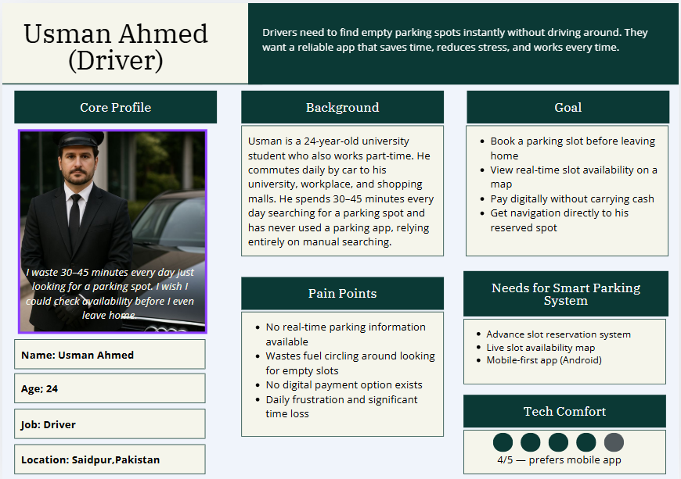

Figure 2 : Persona of Driver

2.2.2 Persona 02

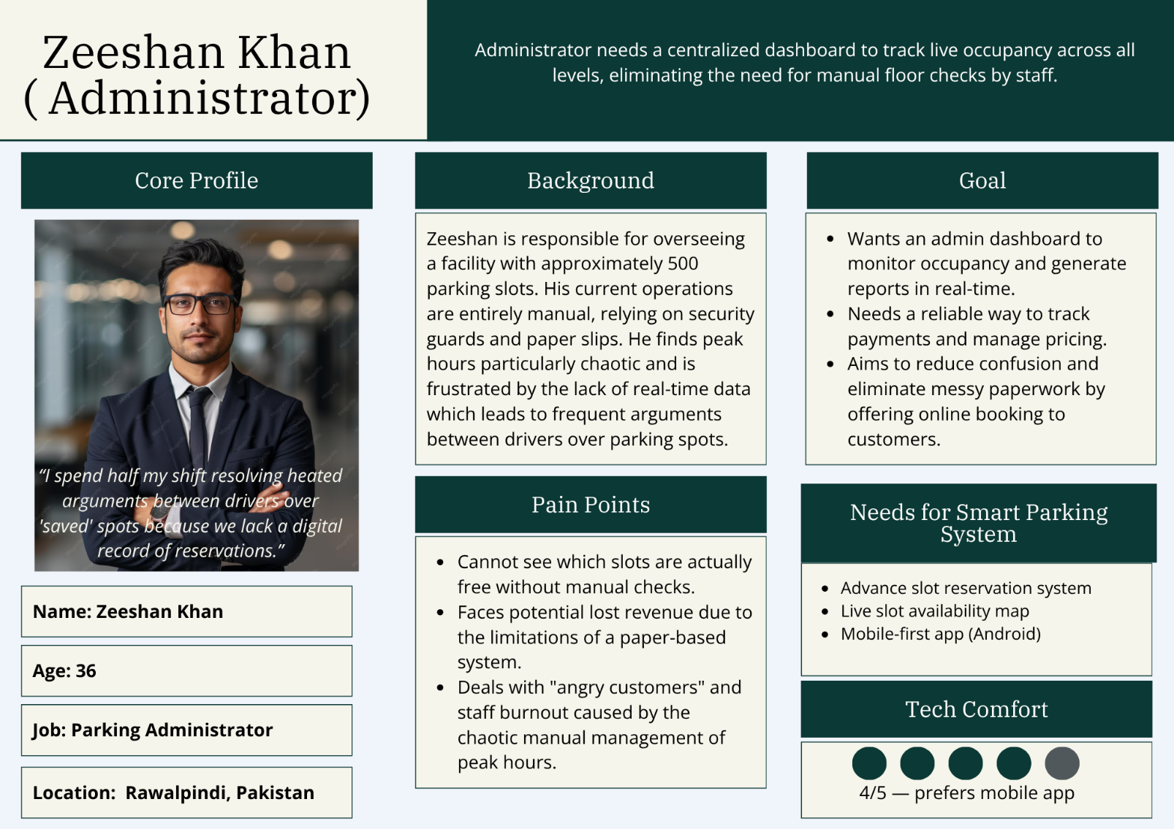
Figure 3 : Persona of Administrator

2.2.3 Persona 03

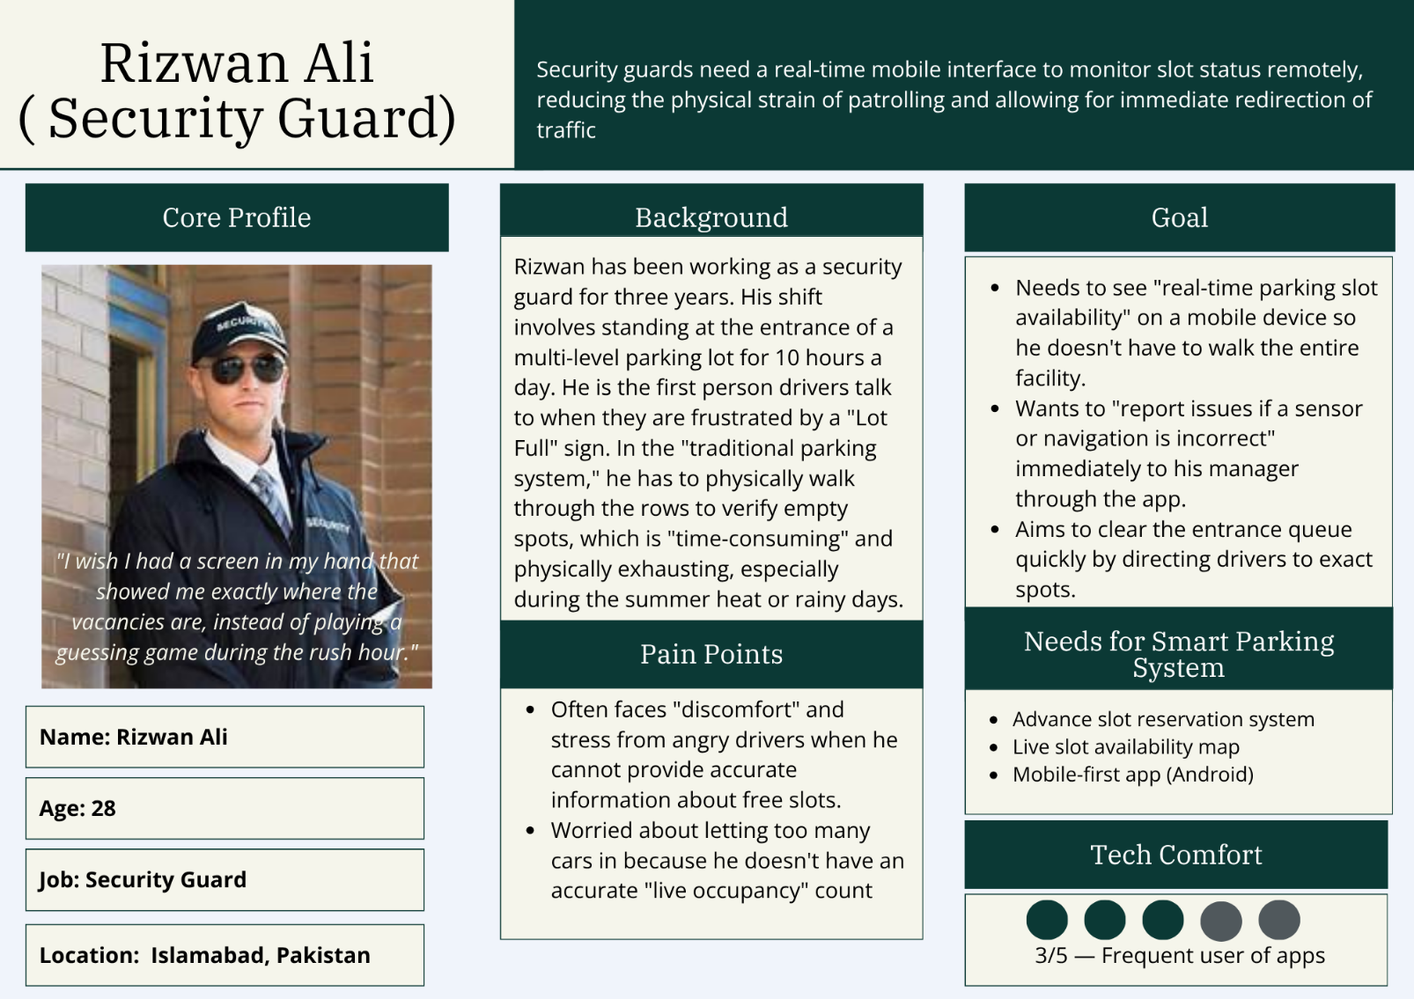

Figure 4 : Persona of Security Guard

Figure 5 : Persona of a Student

2.2.4 Persona 04

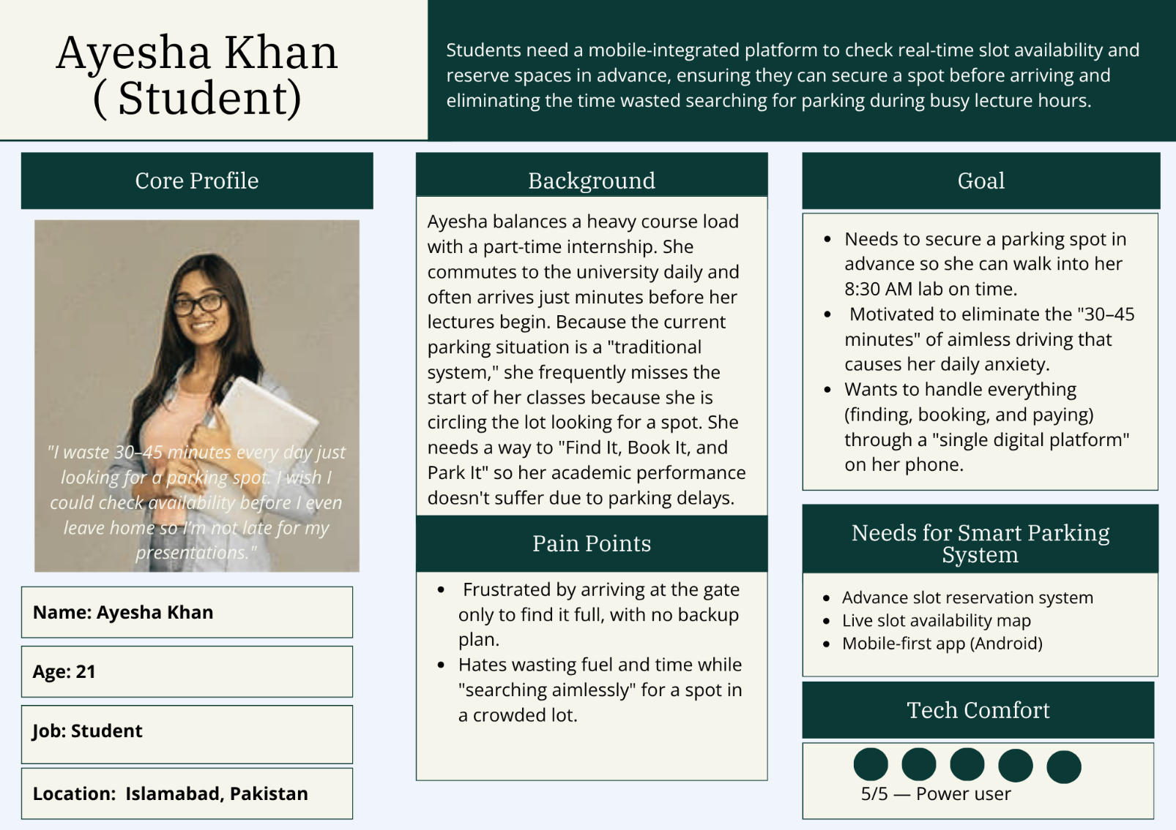

Artifact-3
Prototype

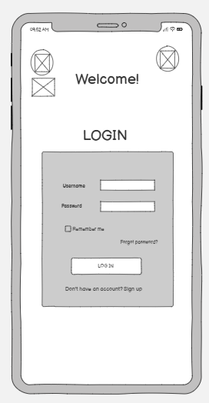
3.1 Low-fidelity wireframes
Figure 7 : Login Screen
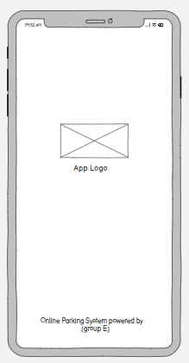
Figure 6 : Splash Screen

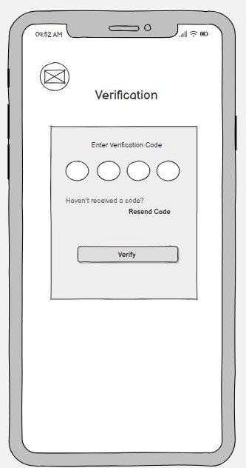
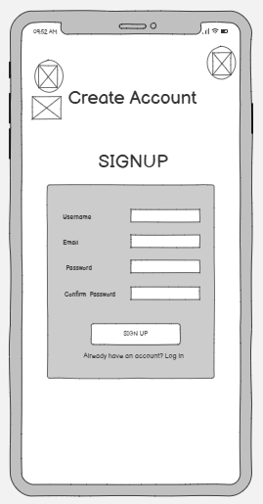
Figure 9 : Verification Screen
Figure 8 : Sign Up Screen

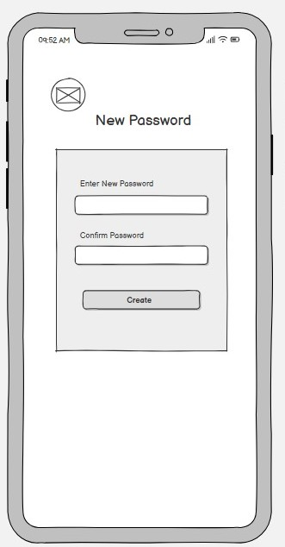
Figure 11 : Forgot Password
Figure 10 : New Password
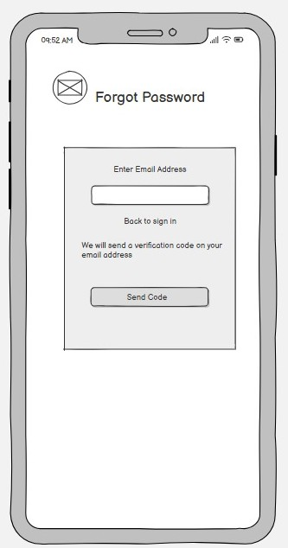

Figure 12 : Dash Board

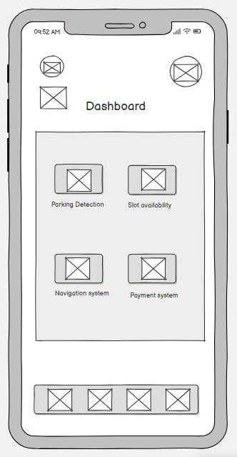

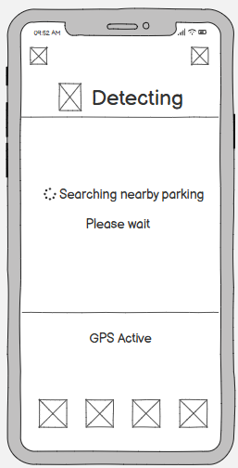
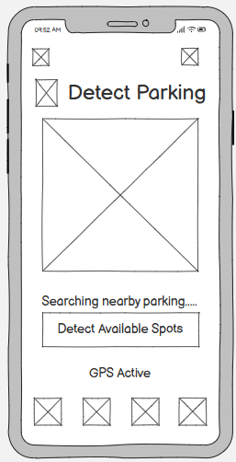
Figure 14 : Detecting
Figure 13 : Detect Parking

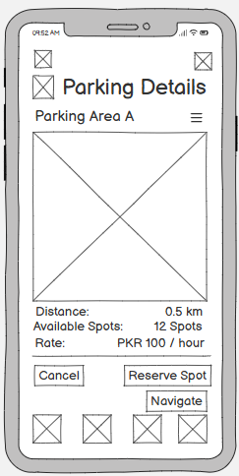
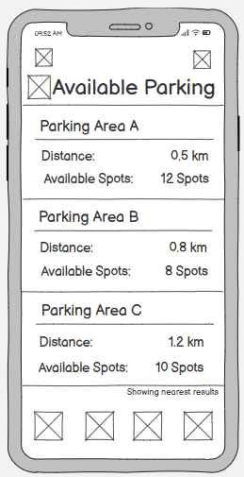
Figure 16 : Parking Details (Area A)
Figure 15 : Available Parking

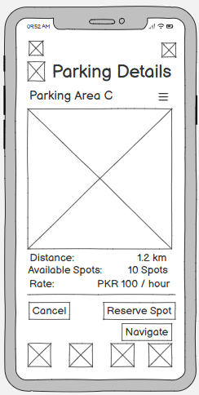
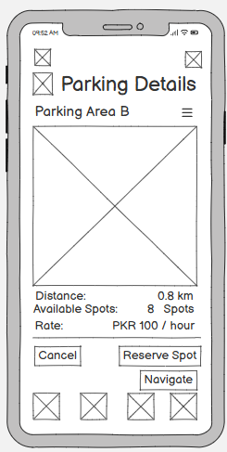
Figure 18 : Parking Details (Area C)
Figure 17 : Parking Details (Area B)

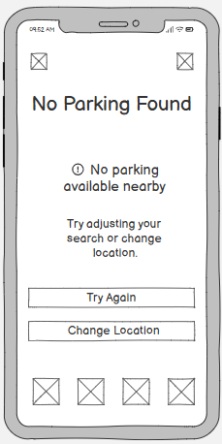
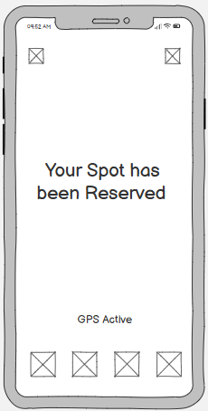
Figure 19 : No Parking Found
Figure 20 : Reservation Confirmed

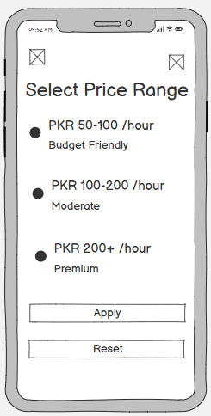
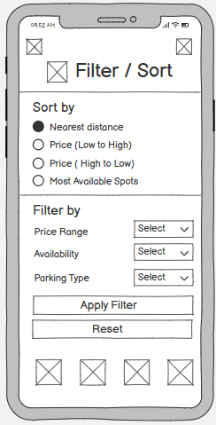
Figure 22 : Select Price Range
Figure 21 : Filter Sort

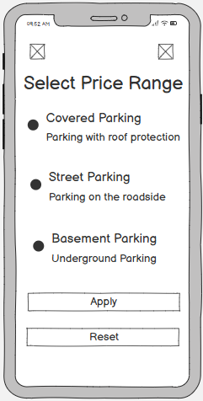
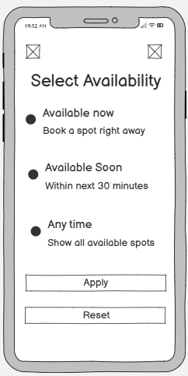
Figure 24 : Select Parking Type
Figure 23 : Select Availability

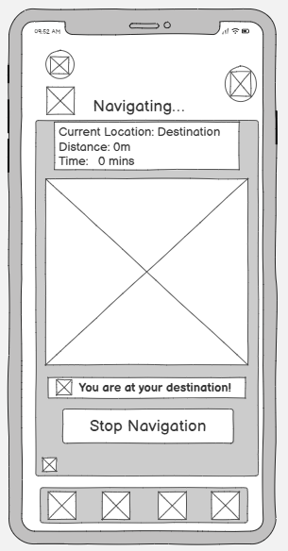
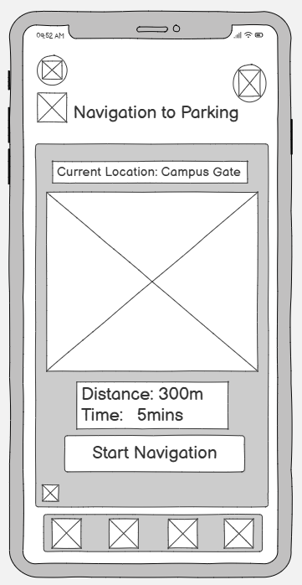
Figure 26 : Navigating
Figure 25 : Navigation to Parking

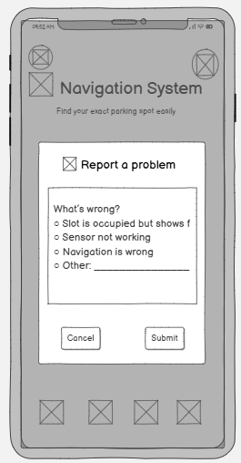
Figure 27 : Navigation System

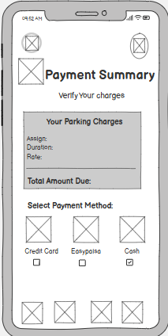
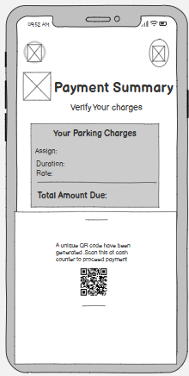
Figure 7 : Payment Summary
Figure 8 : Payment Summary QR

Figure 9 : Card Method

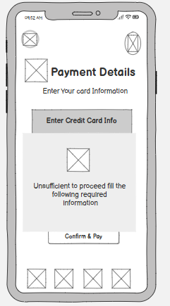
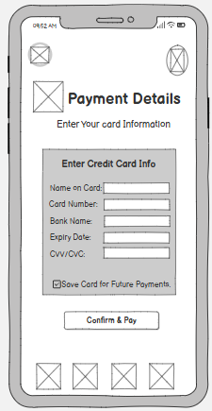
Figure 10 : Fill the Card Details

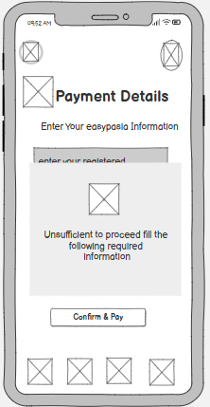
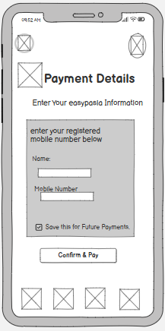
Figure 11 : Fill Easy paisa Details
Figure 12 : Easy Paisa Method

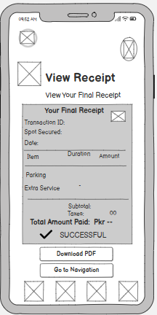
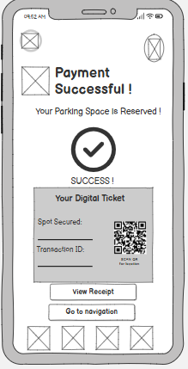
Figure 13 : View Receipt
Figure 14 : Payment Successful

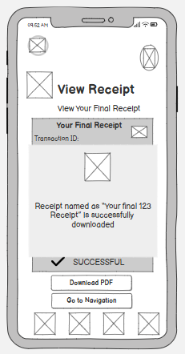
Figure 15 : Download Receipt

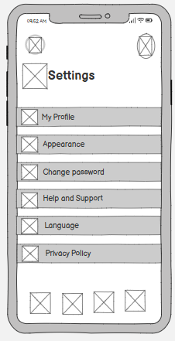
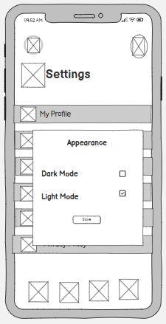
Figure 16 : Settings
Figure 17 : Appreance

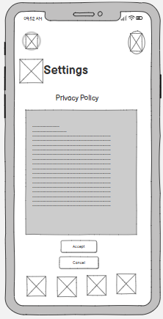
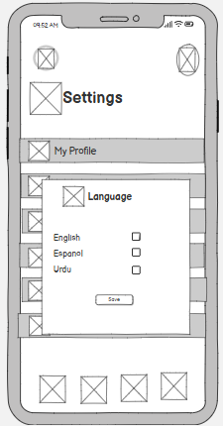
Figure 19 : Privacy Policy
Figure 18 : Language Settings

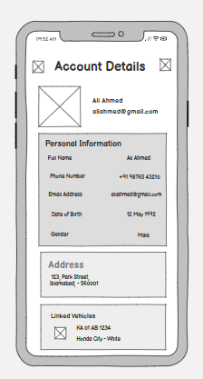
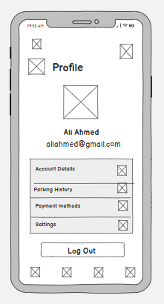
:
Figure 21 : Account Details
Figure 20 : Profile

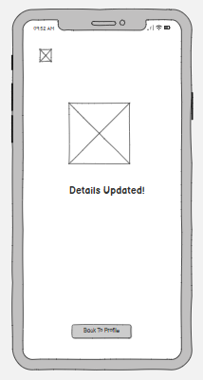
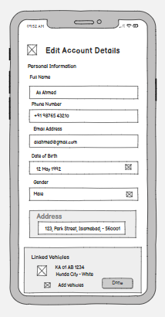
Figure 23 : Details Updated
Figure 22 : Edit Account Details

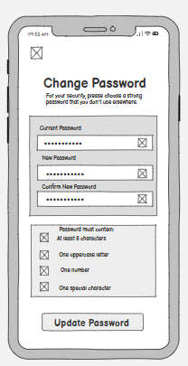
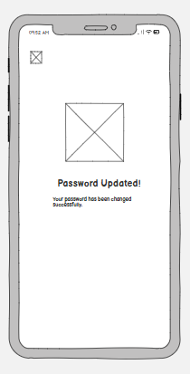
Figure 24 : Change Password
Figure 25 : Password Updated

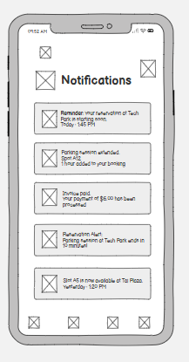
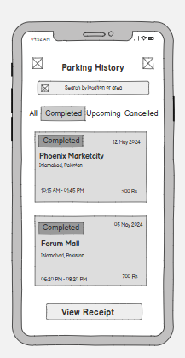
Figure 26 : Notifications
Figure 27 : Parking History
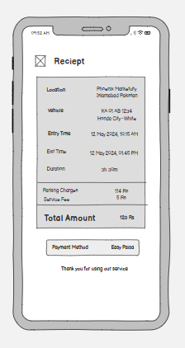
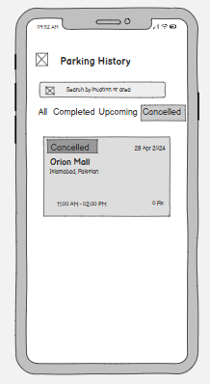
Figure 29 : Receipt
Figure 28 : Parking History cancellation

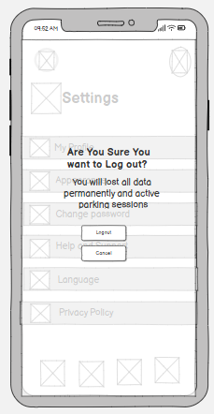
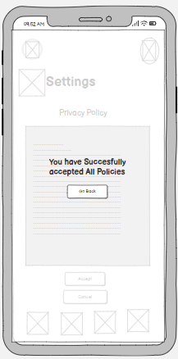
Figure 31 : Login Confirmation
Figure 30 : Privacy Policy Accepted

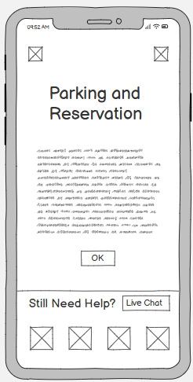
Figure 33 : Parking and Reservation
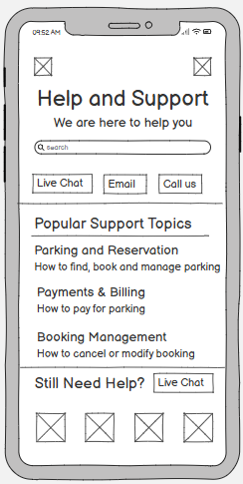
Figure 32 : Help and Support

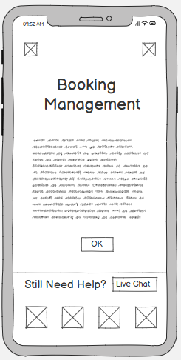
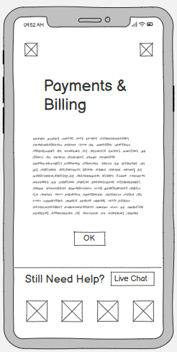
Figure 35 : Booking Management
Figure 34 : Payments and Billings

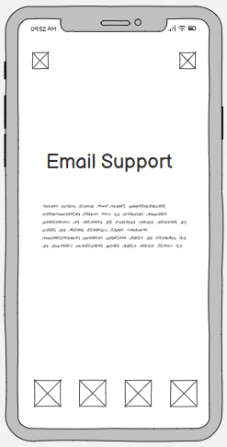
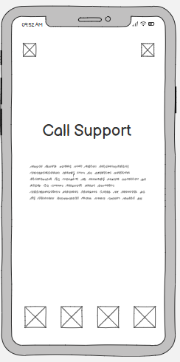
Figure 36 : Email Support
Figure 37 : Call Support
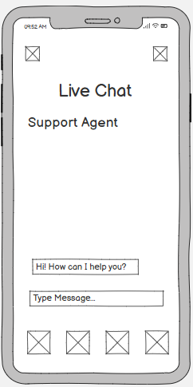
Figure 38 : Live Chat
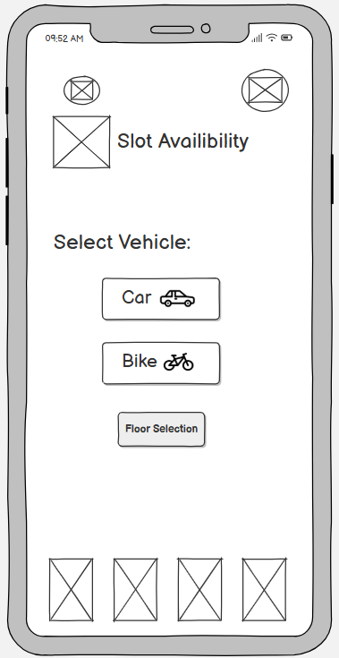
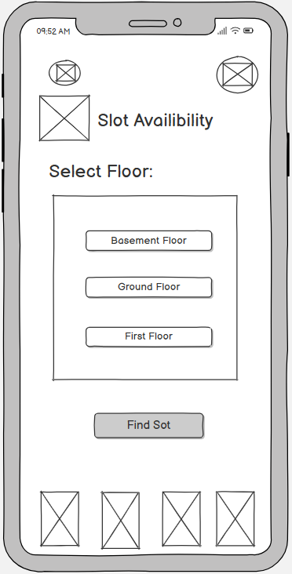
Figure 40 : Vehicle Type Selection
Figure 39 : Floor Level Selection

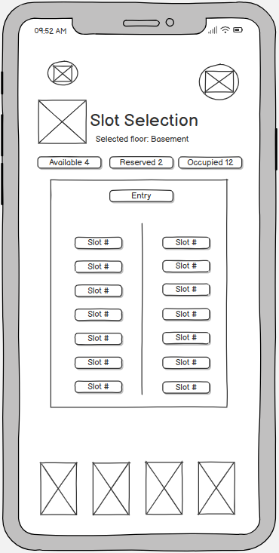
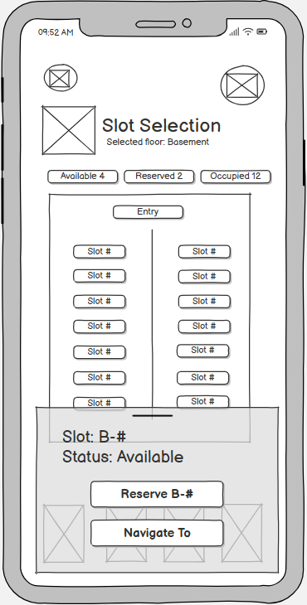
Figure 41 : Slot Selection
Figure 42 : Slot selection

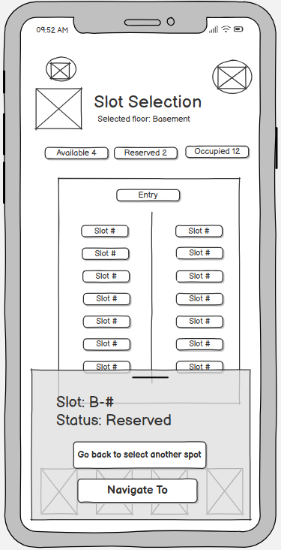
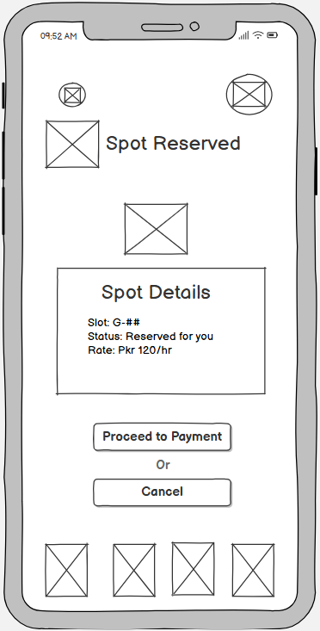
Figure 43 : Reserved spot/other slot suggestion
Figure 44: Spot Reserved confirmation

3.2 High-fidelity prototype
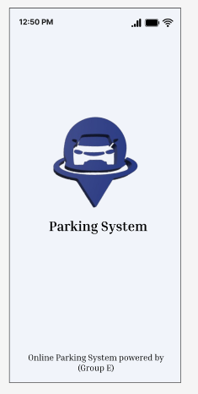

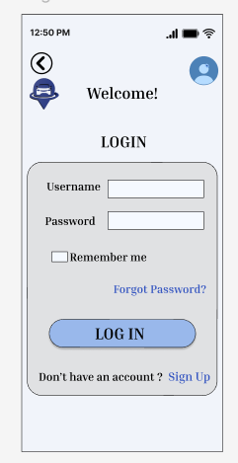

Figure 4.2.1: Splash Screen Figure4.2.2: Login screen

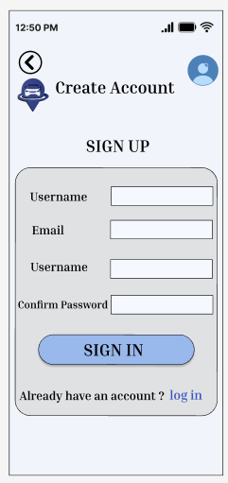
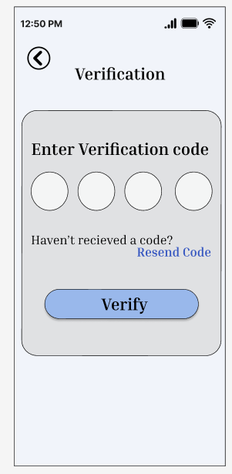

Figure 4.2.3: signup Screen Figure 4.2.4: verification screen

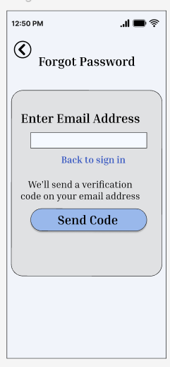
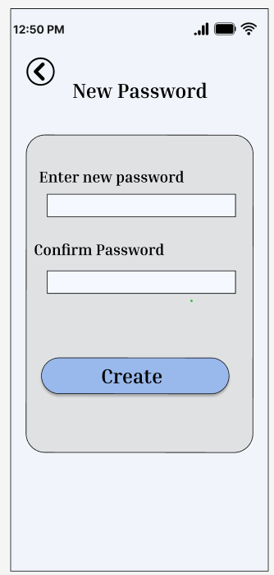

Figure 4.2.5: new password Screen Figure 4.2.6: forgot password screen

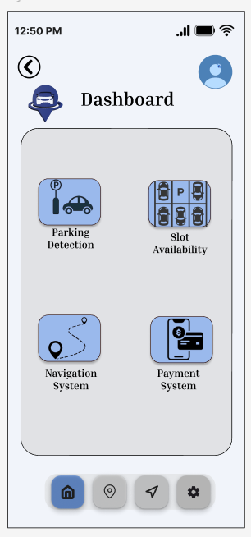

Figure 4.2.7: Dashboard Screen

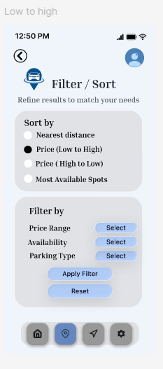
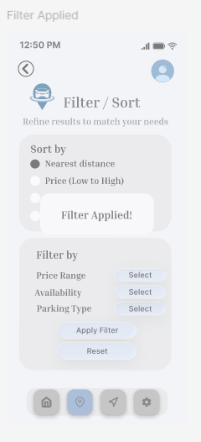

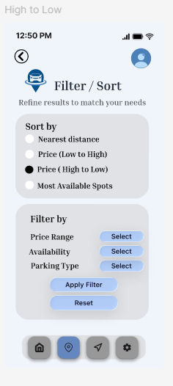
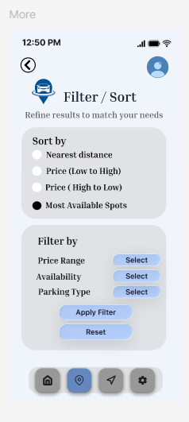

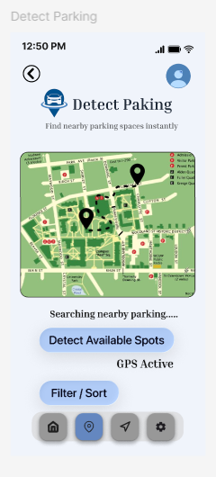
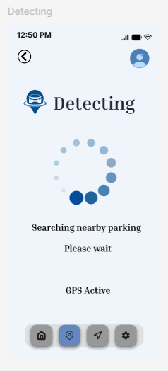
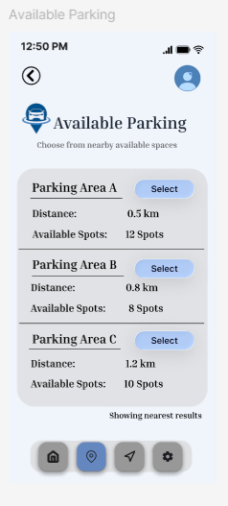
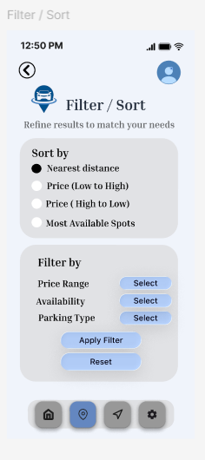

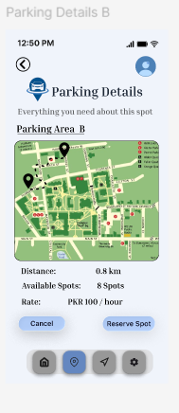
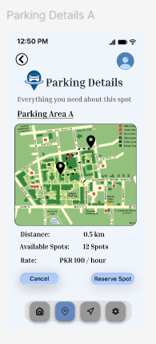

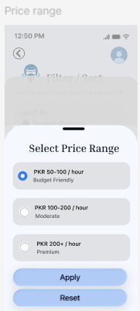
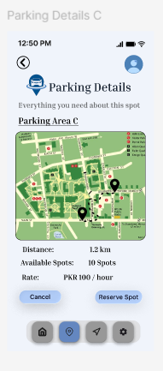

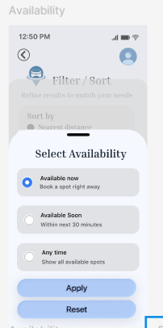
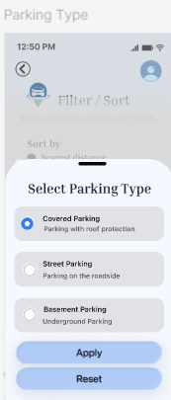

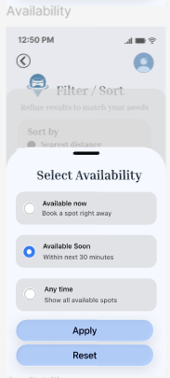
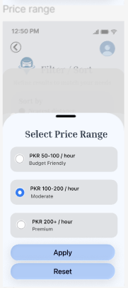

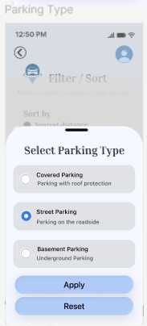
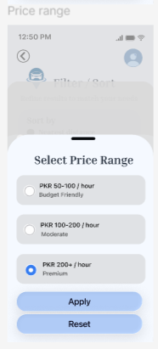

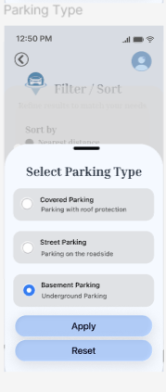
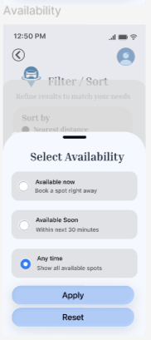

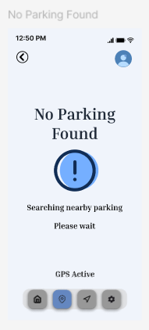
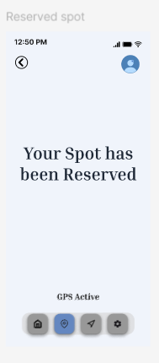

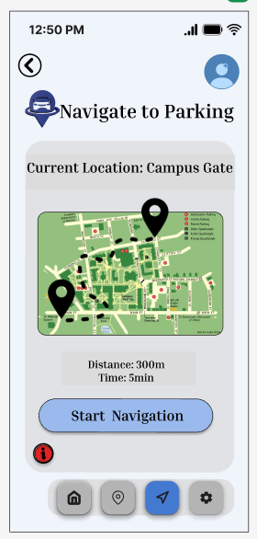

Figure 4.2.8: start navigation screen

Figure 4.2.7: stop navigation Screen Figure 4.2.8: report a problem screen

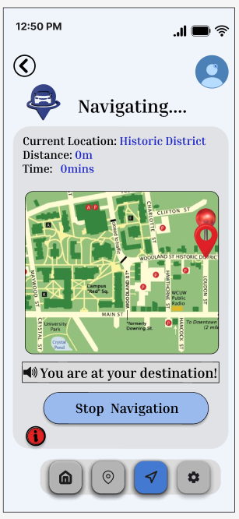
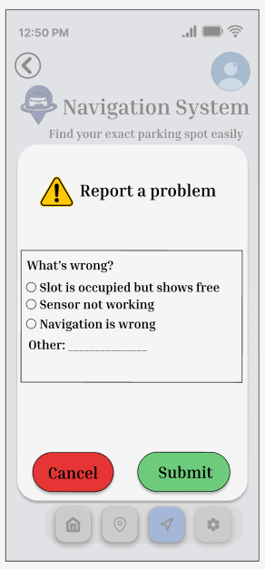

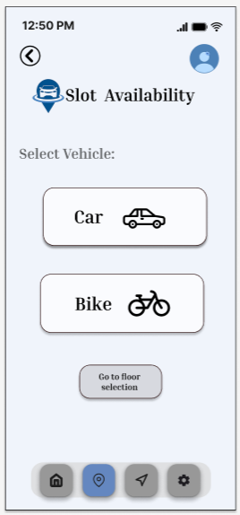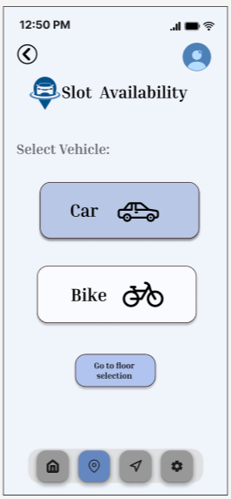

Figure: Vehicle selection Figure: Vehicle selection (Car selected)

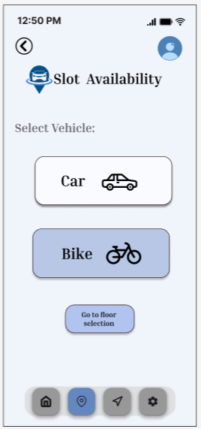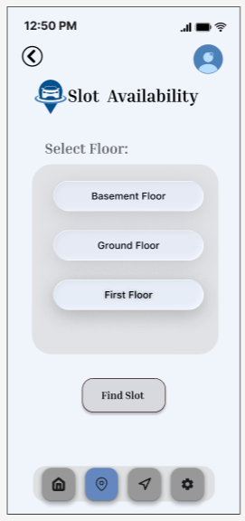

Figure : Vehicle selection (Bike selected) Figure : Floor selection

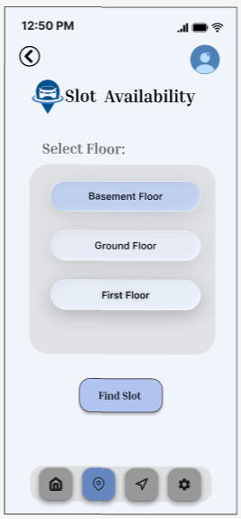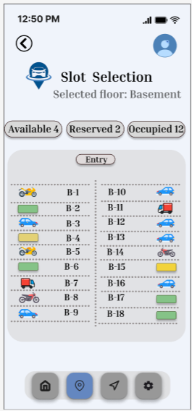

Figure : Floor selection (Basement) Figure: Basement floor

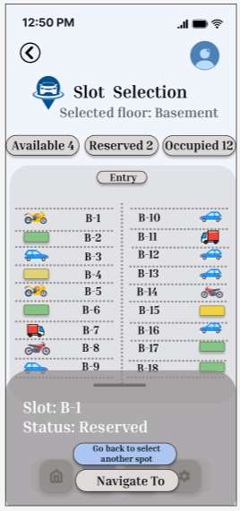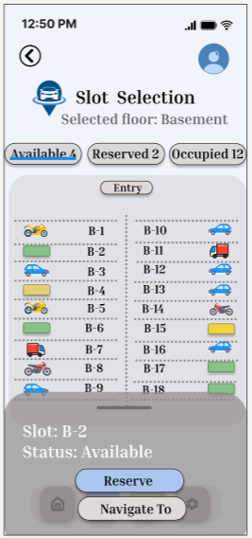

Figure 4 : Reserved slot Figure 4 : Available slot

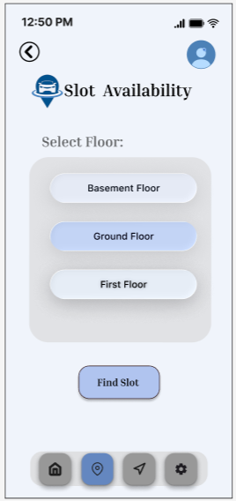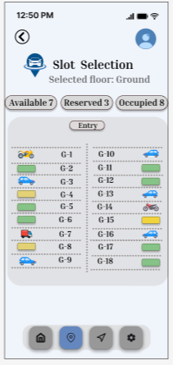

Figure 4 : Selection (Ground floor) Figure 4 : Ground floor

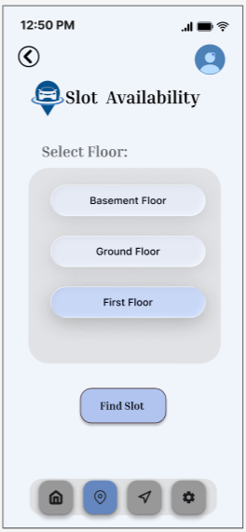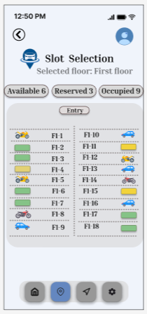

Figure 4 : Selection (1st floor) Figure 4 : First Floor

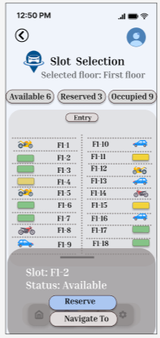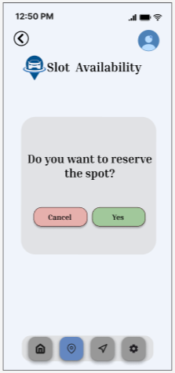
Figure: Available Slot Figure : Apps asks user to confrim

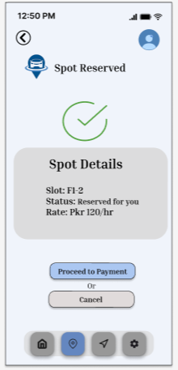
Figure : Confirmation with slot details

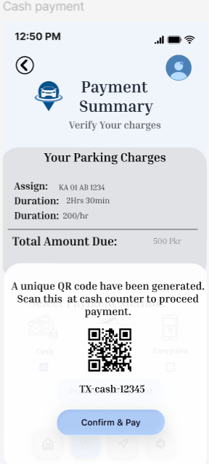
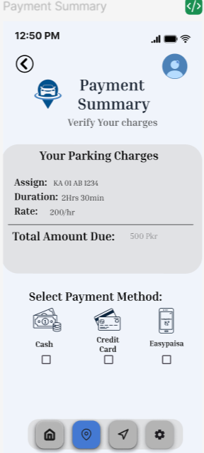

Figure: Payment Summary Figure: Cash Paymentt

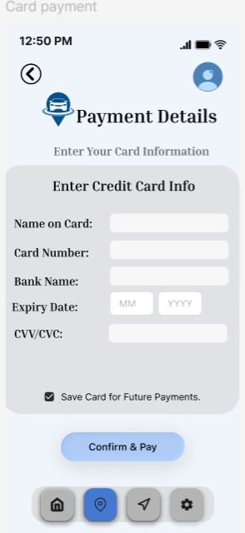

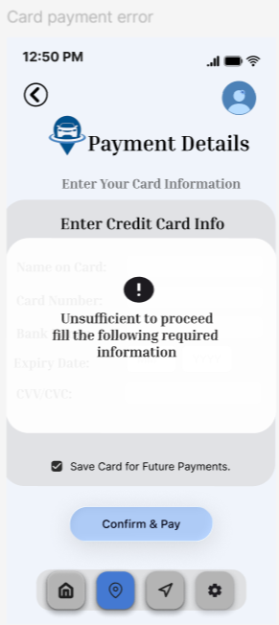
Figure: Card Payment Figure: Card Payment details Error

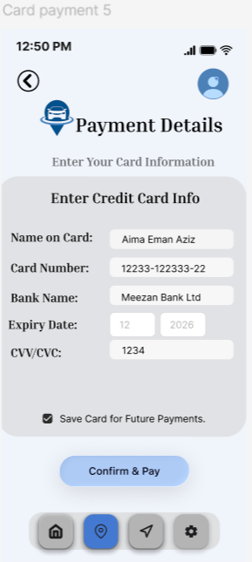

Figure: Card Payment Figure: Card Payment details Filled

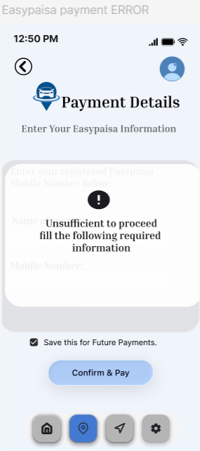
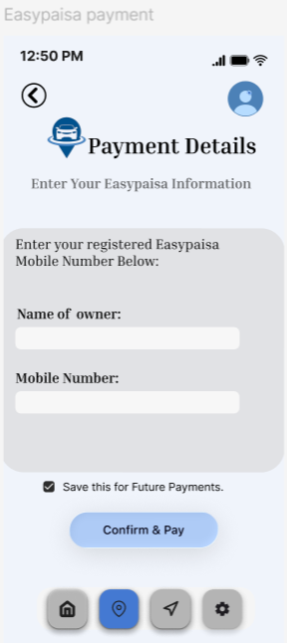

Figure: EasyPaisa Payment Figure: EasyPaisa Payment details Error

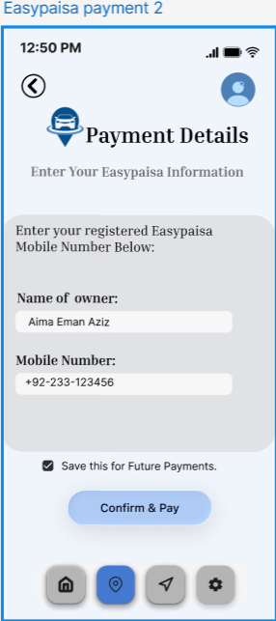

Figure: EasyPaisa Payment Figure: EasyPaisa Payment details Filled

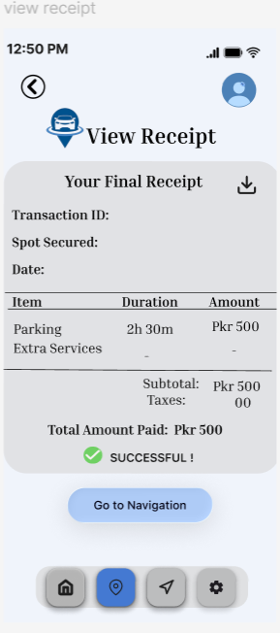
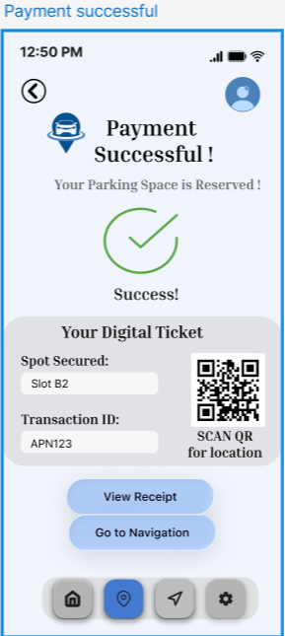

Figure: Payment Successful Figure: View Payment Recipt

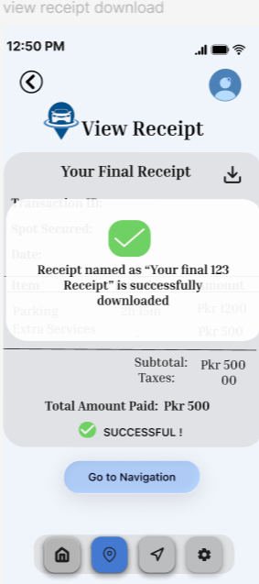

Figure: View Payment Recipt Figure: Download Payment Recipt

Figure: Settings Figure: Light Appearance
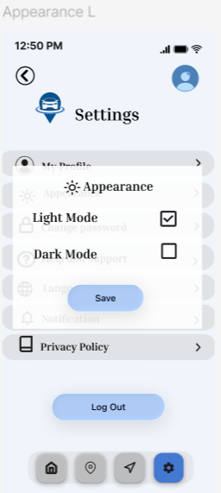
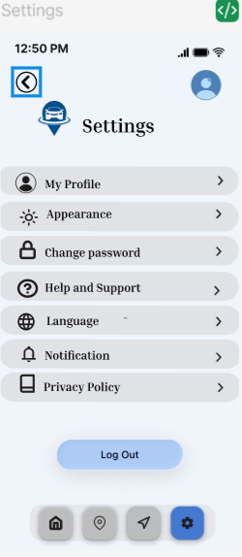

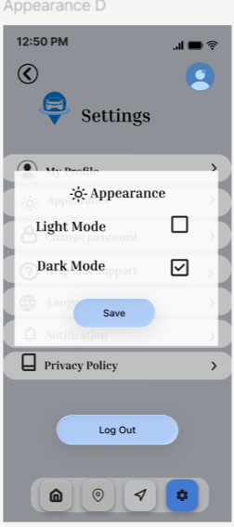

Figure: Dark Appearance Figure: Language
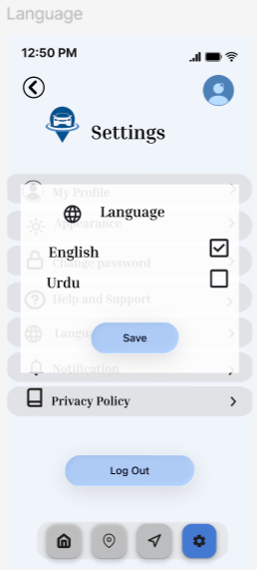

Figure: Privacy Policy
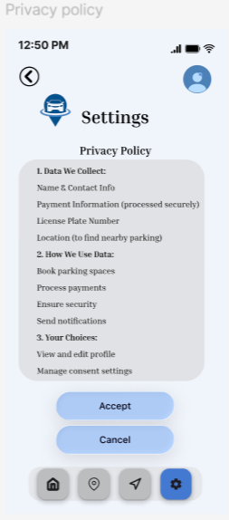

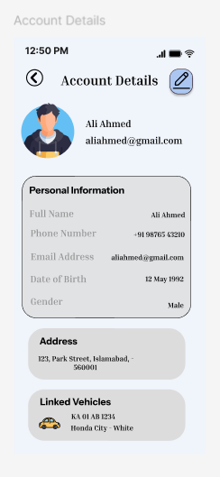
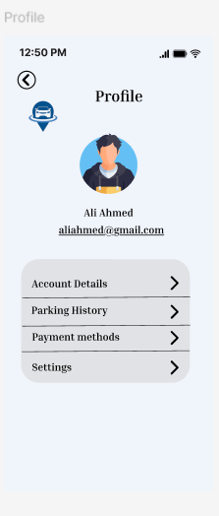

Figure: Profile Figure: Account Details

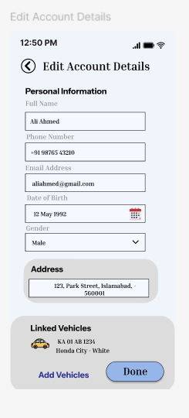
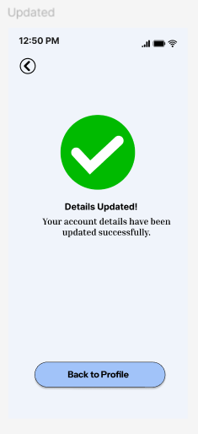

Figure: Edit Account Details Figure: Updated

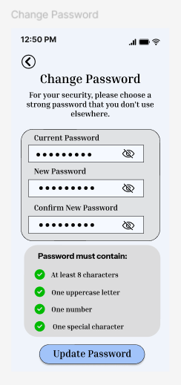
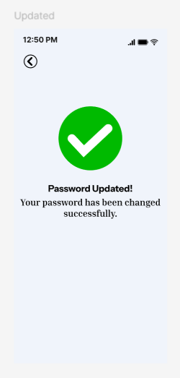

Figure: Change Password Figure: Updated

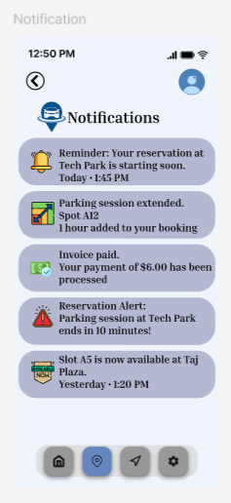
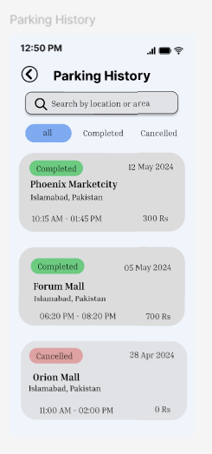

Figure: Notification Figure: Parking History

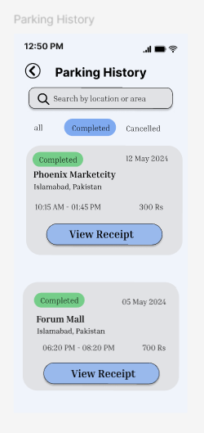

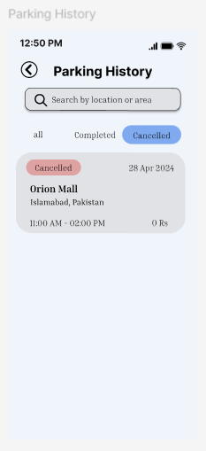

Figure: Parking History Figure: Parking History

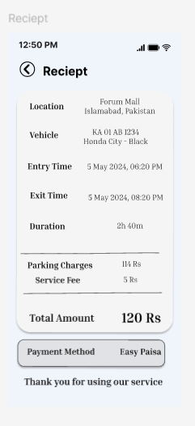
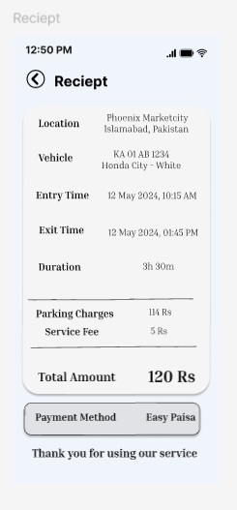

Figure: Reciept Figure: Reciept

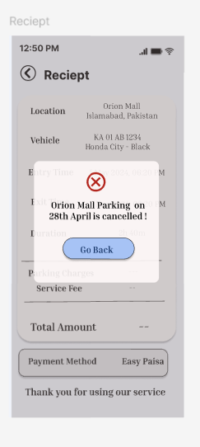

Figure: Reciept

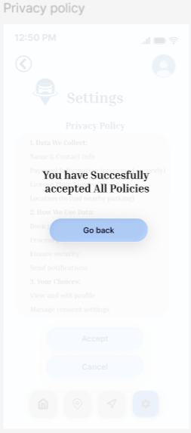
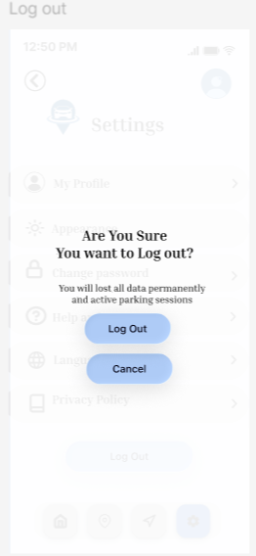

Figure: Privacy policy Accepted Figure: Logout

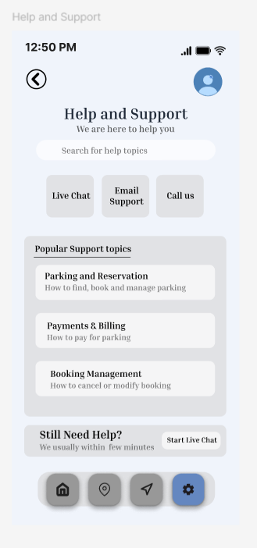
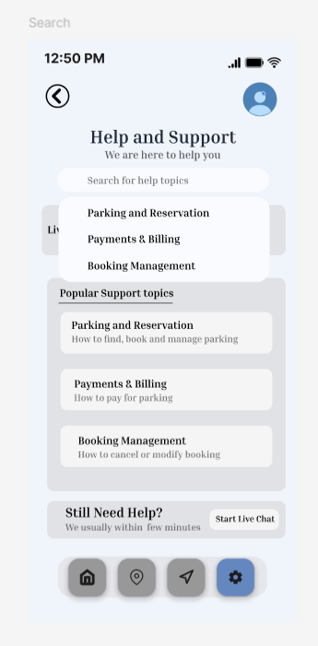

Figure: Help and support Figure: Help and support

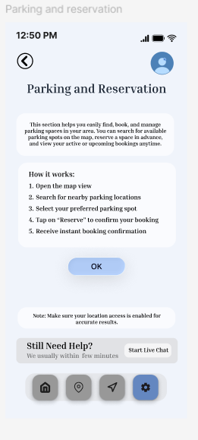
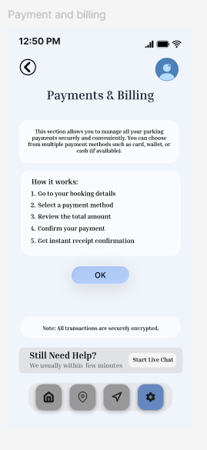

Figure: Parking and Reservation Figure:Payment and Billing

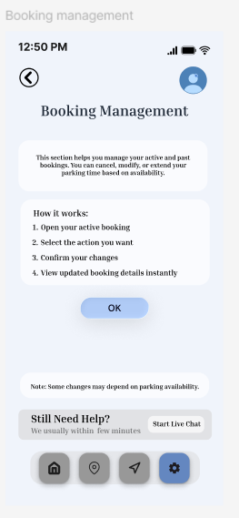
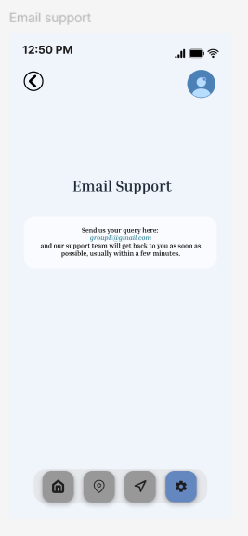

Figure: Booking Management Figure: Email Support

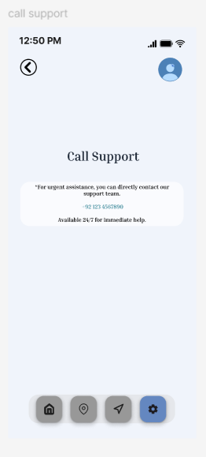
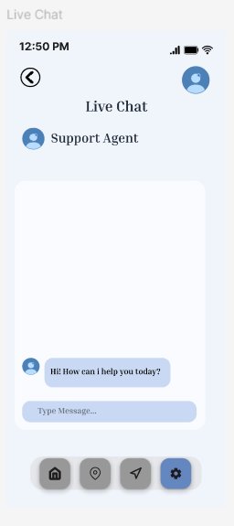

Figure: Call Support Figure: Live Chat
Figma Video link

https://drive.google.com/drive/folders/1oFMB0Sdg63_bccMlMm0o0o3czvpRrRem?usp=sharing

Blender logo
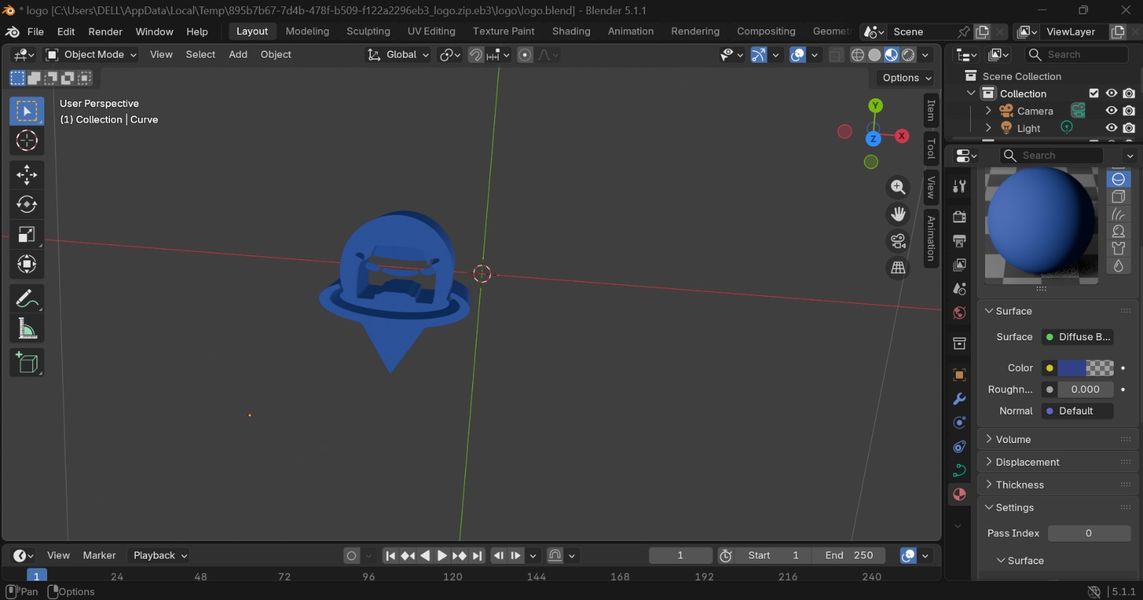

3D logo



Lesson Learned
There were a number of lessons that we learned while working on this Human Computer Interaction course project. We all tried to create space for other group members to share what they think and what they want to improve. Getting everyone’s suggestions in MS Teams meetings, WhatsApp work group, and face-to-face meetings in university, especially after feedback classes, helped us improve our work. We also learned new tools for drawing diagrams, for prototyping, for mid-fidelity and high-fidelity designs, which improved our research process and critical thinking. We learned that willingness to ask for and receive input suggestions from every team member makes the team productive and ultimately results in good outcomes. This helped us avoid conflicts that — no matter big or small — can still bring a sense of discomfort to the team. This quote of Henry Ford sums it all:
“Coming together is a beginning. Keeping together is progress. Working together is success.”

Conclusion
Our project named Smart Parking System is an intelligent parking solution that provides facilities such as real-time parking slot availability, online slot reservation, navigation to the exact parking spot, digital payment integration, and user management. Unlike traditional parking systems, our system offers all these services under a single digital platform. This system is designed to provide ease to drivers, parking administrators, and campus or mall management.
The system to be built allows electronic sharing of parking data that promotes ease and error-free management. Users will be able to check free slots, reserve a spot in advance, navigate to their assigned parking area, pay digitally, and even report issues if a sensor or navigation is incorrect. All this can be done while sitting at home, in the car, or any place with a stable internet connection. All these features will be part of the first version of the Smart Parking System.
For the next version, we can add more features to our system, including voice-controlled navigation, license plate recognition for automatic gate opening, a loyalty points system for frequent users, live camera preview of available slots, and integration with Google Maps or Waze for better routing.

